1.Freestyle Project

Install CloudBees Docker Build and Publish plugin in Manage Jenkins>Global Tool Configuration

(Make sure you have installed docker on your machine and run

$ sudo systemctl start docker

$ sudo chmod 666 /var/run/docker.sock to avoid permission issue)

-> Freestyle project

In Source Code Management, Choose Git and add the repository url of the code you want to build an image of.

Its should also have a dockerfile from which the build will happen and image is created.

In build Step, Choose Docker build and publish

> Add the Repository name-> <dockerhub_id/tag> //chandanarm/fruits

>Add also the Registry credentials->Docker hub id and Password

and Build

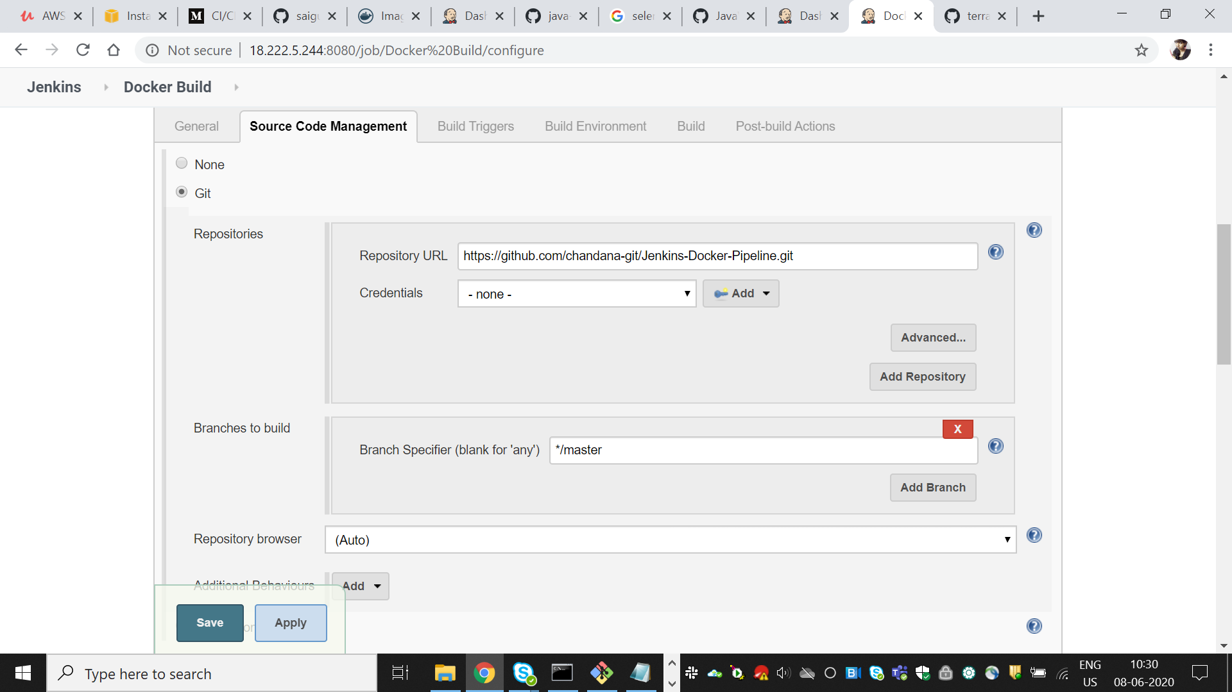

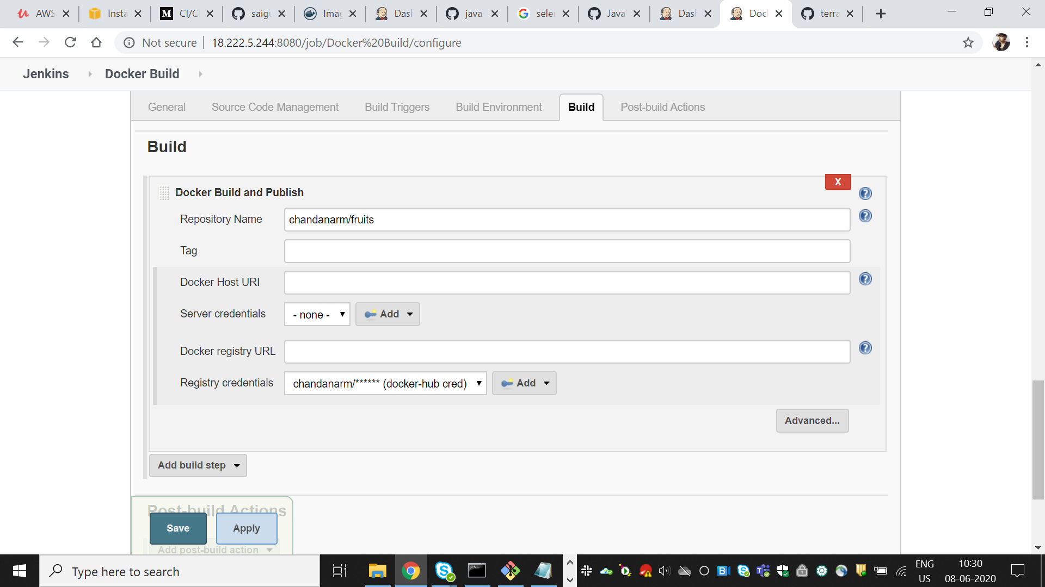

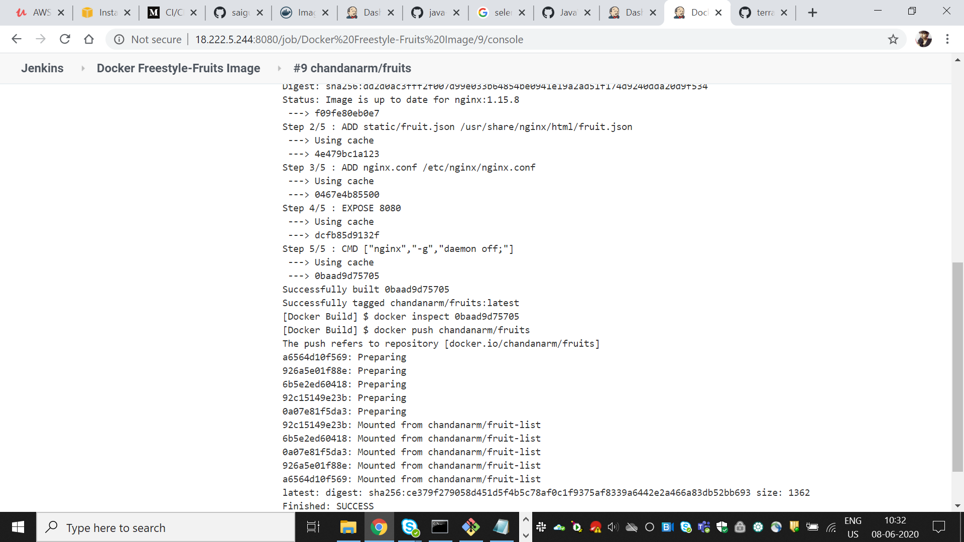

2. Pipeline Project

Create a pipeline project-Docker pipeline

Add Project url to GitHub project

Pipeline script

node {

stage('SCM Checkout')

{

git 'https://github.com/chandana-git/Jenkins-Docker-Pipeline.git/'

}

stage('Build Docker Image'){

//sh 'sudo chmod 666 /var/run/docker.sock'

sh 'docker build . -t chandanarm/fruit-list' ///building from dockerfile in the github

}

stage('Push Docker Image'){

withCredentials([string(credentialsId: 'docker-pwd', variable: 'dockerHubPwd')]) {

sh "docker login -u chandanarm -p ${dockerHubPwd}" //docker hub credentials and login into docker hub to push image

}

sh 'docker push chandanarm/fruit-list:latest'

}

}

Save the changes

